Game Design Document

Fill up the Following document

1. Write the title of your project.

Multiplayer snake game.

1. What is the goal of the game?

Eat as many apples as you can in the given time.

1. Write a brief story of your game?

The snake who is eating the apple and if it touches the walls he dies.

1. Which are the playing characters of this game?

* Playing characters are the ones which respond to the user based on the input from the user
* Cars, monkeys, dinos, wizards etc, are the playing characters in the game.

|  |  |  |
| --- | --- | --- |
| Number | Character Name | What can this character do? |
| 1 | Snake | It can move and eat the apples. |
| 2 |  |  |
| 3 |  |  |
| 4 |  |  |
| 5 |  |  |
| 6 |  |  |
| 7 |  |  |
| 8 |  |  |

1. Which are the Non Playing Characters of this game?

* Non Playing characters are the ones which don't have an action or a behaviour when the user interacts with the game.
* Hurdles, stones, bananas, coins, etc are non playing characters in the game.

|  |  |  |
| --- | --- | --- |
| Number | Character Name | What can this character do? |
| 1 | Walls | They can kill the snake if the player touches them |
| 2 | Apple | They can be spawned anywhere. |
| 3 |  |  |
| 4 |  |  |
| 5 |  |  |
| 6 |  |  |
| 7 |  |  |
| 8 |  |  |

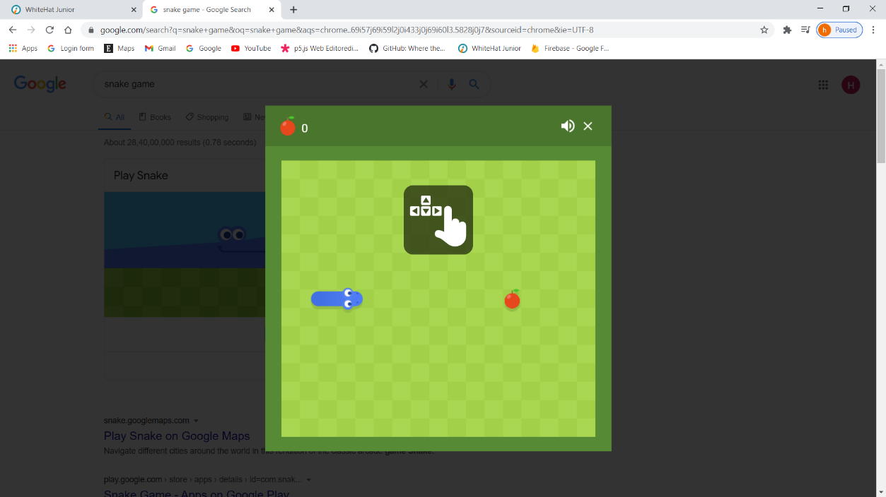Draw your imagination of this game. What does this game look like?

* Draw the game either on your computer or on paper,
* Add images of scenes of the game to show each of the playing and non-playing characters at least once.

The game will somewhat look like this.

How do you plan to make your game engaging?

The friends play together to see who is the better player in this game by seeing that who can eat the more number of apples in the given time. Plus there is a time limit so that the player gets the pressure to eat more and more apples.